DATA MINING FOR ENHANCED BREAST CANCER DIAGNOSIS

PROJECT REPORT


As a part of curriculum
of B.Sc. (Hons) Computer Science 2025-26
SHYAMA PRASAD MUKHERJI COLLEGE FOR WOMEN

UNIVERSITY OF DELHI

SUBMITTED BY

Deepika Joon (23/5051) Baani Kaur (23/5052) Shiwangi Gupta (23/5053) Anshu (23/5054) Aastha (23/5056) Chetna (23/5050)

Under the Supervision of
Dr. Shweta Tyagi

SHYAMA PRASAD MUKHERJI COLLEGE FOR WOMEN
UNIVERSITY OF DELHI
PUNJABI BAGH (WEST), NEW DELHI-110026
CERTIFICATE

This is to certify that the project report entitled, “Breast Cancer wisconsin data using data mining techniques” submitted by “Deepika , Baani, Shiwangi , Anshu , Aastha ” in partial fulfillment of the requirement of B.Sc. (Hons) Computer Science embodies the original work carried out under the guidance and supervision of Dr. Shweta Tyagi.

The results embodied in the dissertation have not been submitted to any other University or Institute for the award of any Degree or Diploma.

Deepika Joon (23/5051) Baani Kaur (23/5052) Shiwangi Gupta (23/5053)

Anshu (23/5054) Aastha (23/5056) Chetna (23/5050)

(Students)

Dr. Shweta Tyagi
Assistant Professor
Department of Computer Science
Shyama Prasad Mukherji College for Women

(Supervisor)
ACKNOWLEDGMENT

We, the members of this project group, would like to express our heartfelt gratitude to everyone who supported us throughout the course of this research project.
First and foremost, we extend our sincere thanks to our project guide, Dr. Shweta Tyagi , for their continuous support, expert guidance, and valuable feedback at every stage of the project. Their encouragement and constructive suggestions were crucial in shaping the outcome of our research.
We are also grateful to the faculty and staff of the Computer Science Department , Shyama Prasad Mukherji College For Women , for providing the necessary resources and a positive academic environment that enabled us to complete our project successfully.
We would like to acknowledge the contribution of our classmates and friends, whose suggestions and moral support were always appreciated.
Thank you.
Chetna (23/5050)
Deepika Joon (23/5051)
Baani Kaur (23/5052)
Shiwangi Gupta (23/5053)
Anshu (23/5054)
Aastha (23/5056)
Computer Science Department
Date:

ABSTRACT

The Breast Cancer Wisconsin Dataset, which includes 569 examples with 30 numeric attributes from fine needle aspirate (FNA) images of breast tumors, is a key resource in creating reliable diagnostic models to distinguish between benign and malignant tumors. This data mining initiative utilizes a complete set of machine learning algorithms such as Naive Bayes, K-Nearest Neighbors (KNN), Decision Trees, and Random Forests to attain very high classification accuracy and reveal prominent patterns in the dataset. The research incorporates feature selection methods, including Information Gain and Gain Ratio, to detect most predictive features, while Principal Component Analysis (PCA) and K-Means clustering give information about data structure and feature interrelations. Association rule mining is also used to detect frequent itemsets and interrelations between high and low feature values, better enabling interpretability. Performance analysis with measures such as accuracy, precision, recall, and F1-score indicates Naive Bayes as the best performing model with an optimal balance between sensitivity and specificity. Visualizations such as PCA plots and Decision Tree diagrams also clarify feature significance and model decisions. The project highlights the promise of data mining for enhancing breast cancer diagnosis, presenting a scalable methodology for early diagnosis and individualized treatment planning with implications for clinical decision support systems.

Introduction

Breast cancer continues to be one of the most common and deadly diseases globally, occurring in millions of people and straining healthcare systems considerably. Based on available global health statistics, breast cancer is responsible for about 25% of all cancer diagnoses among women, with early detection playing a very important role in enhancing survival and treatment outcomes. The development of data-driven methodologies in medical diagnostics has transformed the level of accuracy in detecting and classifying breast tumors, allowing timely interventions that lead to significantly improved patient prognosis. The Breast Cancer Wisconsin Dataset, a widely recognized benchmark in medical data mining, offers a reliable platform in which predictive models can be developed and tested for their capacity to separate benign and malignant breast tumors. This dataset, having 569 cases and 30 numeric attributes extracted from fine needle aspirate (FNA) images of breast masses, is a valuable source of data for studying the use of machine learning and data mining algorithms in clinical diagnosis.

The Breast Cancer Wisconsin Dataset contains comprehensive measurements of cell nuclei properties, i.e., mean, standard error, and worst values for features like radius, texture, perimeter, area, smoothness, compactness, concavity, concave points, symmetry, and fractal dimension. These computed features from digitized FNA images capture morphological properties of breast masses, allowing binary discrimination of tumors into benign (357 instances) or malignant (212 instances). The structured form of the dataset, with no missing values in the essential attributes (despite the existence of an extraneous Unnamed: 32 column), makes it a prime target for the deployment of a variety of data mining algorithms, from supervised learning through to unsupervised clustering and association rule discovery. The main aim of this data mining project is to exploit this dataset to train high-accuracy predictive models, discover the most relevant features for diagnosis, and find significant patterns that can be used to support clinical decision-making.

The importance of this project is that it can make an early diagnosis of breast cancer, which can be a determining factor in lowering mortality rates. The existing diagnostic processes, i.e., mammography and biopsy, are effective but invasive, expensive, and human error-prone. Machine learning algorithms, when implemented on large datasets like the Breast Cancer Wisconsin Dataset, provide a non-invasive, inexpensive, and highly reliable means of tumor classification. By combining different algorithms such as Naive Bayes, K-Nearest Neighbors (KNN), Decision Trees using Gini and Entropy criteria, and Random Forests, this project tries to compare and maximize model performance in order to find the best possible method for diagnosing breast cancer. Furthermore, feature selection methods, including Information Gain, Split Information, and Gain Ratio, are utilized to rank and choose the most predictive attributes to decrease model complexity and enhance interpretability at the expense of no accuracy loss

In addition to supervised learning, the project applies unsupervised learning techniques to better understand the structure of the dataset. K-Means clustering is employed to discover natural groupings in the data that may show clusters corresponding to benign or malignant diagnoses. Principal Component Analysis (PCA) is used to reduce the dimensionality and visualize class separability in a lower-dimensional space, which gives a visual indication of the quality of how well the features separate tumor types. These unsupervised methods augment the predictive models by providing an overall comprehension of the data, which is imperative for the validation of the solidity of the classification outcomes and recognizing any intrinsic patterns that cannot be easily deduced through the supervised methods individually.

In further adding to the interpretability of the results, the project utilizes association rule mining through the Apriori algorithm in order to uncover relationships between feature values. By binarizing the numeric attributes (e.g., labeling values as "high" or "low" against thresholds such as the mean or median), the project determines association rules and frequent itemsets, for example, the co-appearance of high values in attributes such as radius_worst and concave points_worst for malignant instances. These guidelines offer actionable information about which combinations of features are most strongly linked to particular diagnostic outcomes, potentially giving clinicians guidance in prioritizing particular diagnostic markers.

The project also solves real-world problems in data preprocessing and analysis. For example, the Unnamed: 32 column of the dataset, which has missing values only, is dropped to maintain data quality. Feature scaling is used to normalize the numerical features so that algorithms such as KNN and SVM work best. To handle computational limits, especially in the case of association rule mining, the Apriori algorithm is tuned using parameters like min_support=0.3 and max_len=4 to prevent memory errors while still producing relevant rules. The performance of the models is seriously tested using a set of measures, such as accuracy, precision, recall, F1-score, and area under the ROC curve (AUC-ROC), to get a complete overview of how each algorithm performs. Visualizations, e.g., PCA scatter plots, K-Means clustering plots, Decision Tree diagrams, and ROC curves, are produced to offer intuitive explanations of feature significance, class distinguishability, and model choices.

The results of this project shall have theoretical and practical implications. Theoretically, the research adds to the expanding portfolio of medical data mining knowledge by illustrating the effectiveness of integrating supervised, unsupervised, and rule-based methods for classifying breast cancer. In practice, the developed predictive models and findings from this research could be incorporated into clinical decision-making support systems, and assist healthcare practitioners in delivering quicker and more precise diagnoses. By determining the most predictive characteristics and how they are related, the project also establishes the foundation for creating focused diagnostic protocols that center on major markers of malignancy. Ultimately, this data mining endeavor aims to push the science of precision medicine forward with an interpretable and scalable system for early breast cancer diagnosis and personalized treatment planning, with the long-term objective of enhancing patient outcomes and decreasing the worldwide burden of this tragic disease.

Background and Related Work
The Breast Cancer Wisconsin (Diagnostic) Dataset is a foundational resource in the realm of data mining and medical data analysis. Developed in the early 1990s by Dr. William H. Wolberg, a physician and researcher at the University of Wisconsin Hospitals in Madison, the dataset was intended to support the creation of computer-assisted diagnostic tools that could help detect breast cancer accurately and efficiently.
The dataset originates from a clinical procedure known as Fine Needle Aspiration (FNA) — a minimally invasive technique used to extract a small sample of breast tissue for examination. This method involves inserting a thin, hollow needle into a breast lump or abnormal area to collect cellular material, which is then spread onto a slide and observed under a microscope.
What sets this dataset apart is the quantitative analysis applied to the FNA samples. Rather than relying solely on subjective human evaluation, digital image processing techniques were used to extract numerical features from the images of the cell nuclei. A total of 30 features were computed for each sample, capturing various properties such as:
- Size (e.g., radius, area, perimeter),
- Shape and symmetry (e.g., compactness, concavity),
- Texture (e.g., standard deviation of gray-scale intensities),
- Smoothness and uniformity of the nuclei structure.
These features were mathematically derived from the mean, standard error, and worst (maximum) values observed across all the cells in the sample. This allowed the creation of a structured dataset that could be used as input for computational models.
The dataset contains 569 instances, each labeled as either:
- Malignant (1) – indicating cancerous tumors, or
- Benign (0) – indicating non-cancerous growths.
This clear and binary classification target made the dataset suitable for training and validating predictive models, especially for early-stage cancer detection. Moreover, the absence of missing values and the numerical nature of all attributes make it ideal for data preprocessing, statistical analysis, and pattern discovery.
From a data mining perspective, the significance of this dataset lies in its ability to:
- Enable the discovery of hidden patterns in clinical data,
- Support evidence-based medical decision-making,
- Reduce reliance on invasive procedures by promoting image-based diagnostics,
- Serve as a benchmark for validating new data mining methodologies in healthcare.
Over the years, the Breast Cancer Wisconsin (Diagnostic) Dataset has become a standard benchmark for medical research, education, and algorithm development. It is frequently included in data mining curricula, research papers, and Kaggle competitions, highlighting its continued relevance and impact.
Despite being relatively small by modern standards, the dataset remains highly valuable due to its well-defined structure, clear labels, and strong connection to real-world medical c
Challenges. It demonstrates how data mining techniques can be leveraged to enhance diagnostic accuracy, reduce human error, and ultimately contribute to better patient outcomes.

Related researches on breast cancer
1. Discriminative Pattern Mining in Histopathology Images
The work by Li et al. (2019) proposed a method for breast cancer classification using discriminative pattern mining on histopathology images. Their model employed a fully convolutional autoencoder to detect contrastive tissue patterns in an unsupervised manner, effectively generating probability maps that differentiated malignant from benign samples. This approach highlighted the strength of deep learning in interpreting complex medical imagery
2. Predicting Medication Adherence in Breast Cancer Patients
A retrospective study in Taiwan explored the use of decision trees, artificial neural networks, and logistic regression to predict medication adherence among breast cancer patients undergoing adjuvant hormone therapy. The study identified crucial predictive factors like therapy duration and patient age, enabling the development of targeted interventions to improve treatment compliance
3. Hybrid Data Mining Model for Breast Cancer Prediction
Bahmani et al. (2020) developed a hybrid data mining model combining Naive Bayes, Radial Basis Function networks, and K-means clustering for breast cancer prediction. The ensemble learning model showed impressive results, achieving an accuracy of 99% and a mean absolute error of only 0.019, outperforming each individual algorithm. This study highlighted the benefits of using hybrid models that integrate multiple machine learning techniques to improve prediction accuracy.
4. Explainable AI in Breast Cancer Detection
The increasing use of explainable artificial intelligence (XAI) in breast cancer research was explored by Ghasemi et al. (2024), who conducted a systematic review on the application of XAI methods, particularly SHapley Additive exPlanations (SHAP), for interpreting machine learning models. They emphasized the importance of making predictive models interpretable, as it enhances clinical decision-making by ensuring that doctors can trust the model’s predictions.
5. Cost Analysis of HER2-Positive Breast Cancer Treatments
A study conducted in Iran employed data mining techniques to analyze insurance claims data and estimate the direct healthcare costs associated with treating HER2-positive breast cancer. The analysis utilized classification algorithms to determine the clinical stages of the disease and the corresponding treatment costs from the claims data. The findings revealed that trastuzumab, a key treatment for HER2-positive breast cancer, accounted for the largest share of the total treatment costs, comprising 58% of the overall expenses. This highlights the significant economic impact of trastuzumab in the management of HER2-positive breast cancer. The study's results were published in the Value in Health Journal.
6. Predicting Severity of Breast Masses
Mokhtar and Elsayad (2013) contributed to the field by evaluating decision trees, artificial neural networks, and support vector machines to predict the severity of breast masses using mammographic data. Their study found that support vector machines achieved the highest accuracy (81.25%) among the tested methods, showcasing the power of machine learning algorithms in analyzing mammograms and assisting in clinical diagnosis.

7. Application of Data Mining Techniques for Breast Cancer Prediction
A comparative study assessed the effectiveness of k-nearest neighbor, support vector machine, and random forest algorithms for breast cancer prediction. The research aimed to evaluate the performance of these different algorithms to identify the most accurate method for making predictions. The findings revealed that ensemble learning methods, especially those based on maximum voting, yielded the highest accuracy rates, highlighting the benefits of combining multiple classifiers to improve prediction performance. The study's results were published on ScienceDirect.
8. Integrating Text Mining and Network Analysis for Genetic Trends
Jurca et al. (2016) took a novel approach by integrating text mining, data mining, and network analysis to identify genetic trends in breast cancer research. By analyzing gene co-occurrence in scientific literature, they uncovered potential genetic associations and emerging research trends, which could inform future studies and hypotheses in cancer genomics.

Proposed Technique

3.1 Naïve Bayes Classifier
Naïve Bayes is a probabilistic classification technique based on Bayes’ Theorem, assuming feature independence. It is efficient, especially for small or noisy datasets.

Procedure:

- Preprocess the dataset (handle missing values, encode categorical variables).

- Split the data into training and testing sets.

- Calculate prior probabilities for each class.

- Compute the likelihood of features given each class.

- Apply Bayes' Theorem to predict classes for test data.

Evaluate using metrics like accuracy, precision, and recall.
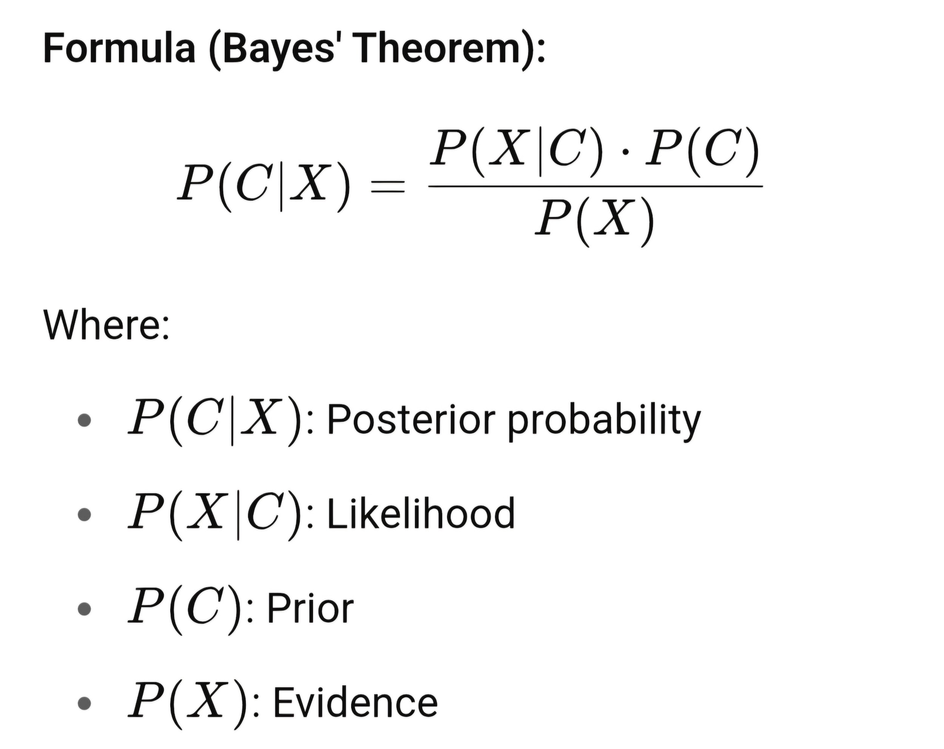
Advantages:

● Fast and scalable

● Performs well with high-dimensional data

Limitations:

● Assumes feature independence

● May not perform well if this assumption is violated

2. K-Nearest Neighbour (KNN)
KNN is a non-parametric, instance-based algorithm used for classification and regression. It classifies data points based on the majority class among the nearest neighbors.

Procedure:

- Normalize the feature values.

- Choose the number of neighbors (K).

- Calculate distances between the test point and all training points.

- Identify the K nearest neighbors.

- Use majority voting for classification.

- Evaluate the model performance using cross-validation techniques.
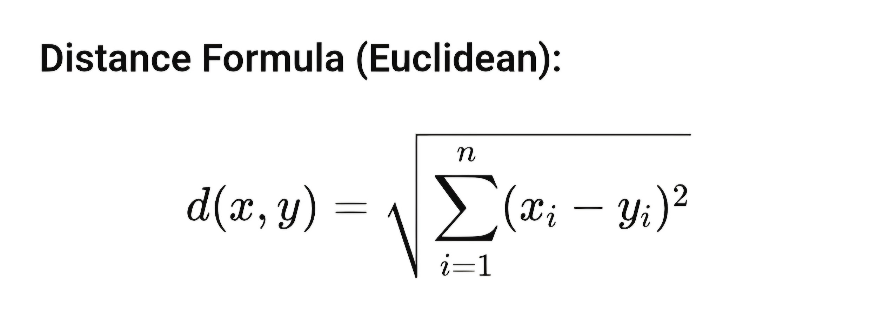
Advantages:

●Simple and intuitive

●No training phase

Limitations:

●High computational cost for large datasets

●Sensitive to irrelevant features and the choice of K
3. Decision Tree (Entropy-Based / ID3)
Decision Trees use a tree-like model for decisions. The entropy-based ID3 algorithm selects features with the highest information gain for splitting.

Procedure:

- Compute the entropy of the dataset.

- Calculate information gain for each feature.

- Choose the feature with the highest gain as the root.

- Recursively split data based on selected features.

- Continue until leaf nodes are pure or other stopping conditions are met.

Use the resulting tree to classify new data.
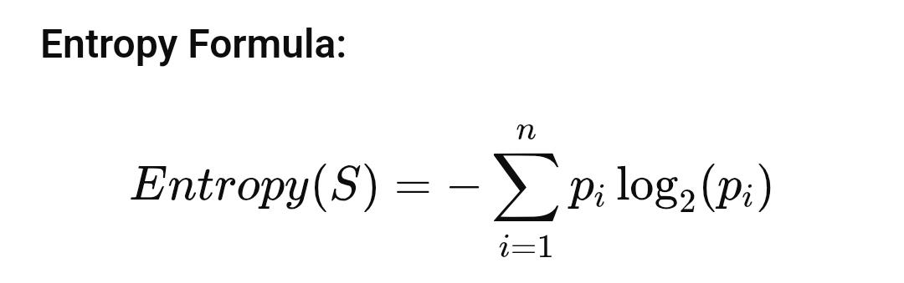
Advantages:

●Easy to interpret and visualize

●Handles both categorical and numerical data

Limitations:

●Prone to overfitting

●Small changes in data can result in different trees

4. 5-Fold Cross Validation
This technique assesses model performance by dividing data into 5 parts and rotating the test set across folds.

Procedure:

- Divide the dataset into 5 equal folds.

- Train the model on 4 folds and validate on the remaining 1 fold.

- Repeat the process 5 times, rotating the validation fold.

- Compute the average performance across all 5 folds to reduce overfitting and assess model robustness.
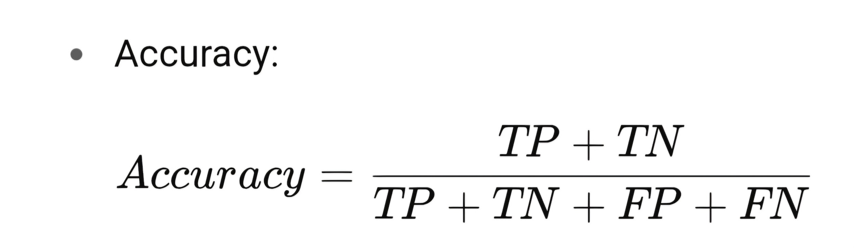
Advantages:

●Better performance estimation than a single train-test split

Limitations:

●More computationally expensive

5. K-Means Clustering
K-Means is an unsupervised algorithm that groups data into K clusters based on feature similarity.

Procedure:

- Choose the number of clusters (K).

- Randomly initialize K centroids.

- Assign each data point to the nearest centroid.

- Update centroids by averaging the assigned points.

- Repeat assignment and update until centroids converge.

- Use the elbow method to determine optimal K, if needed.
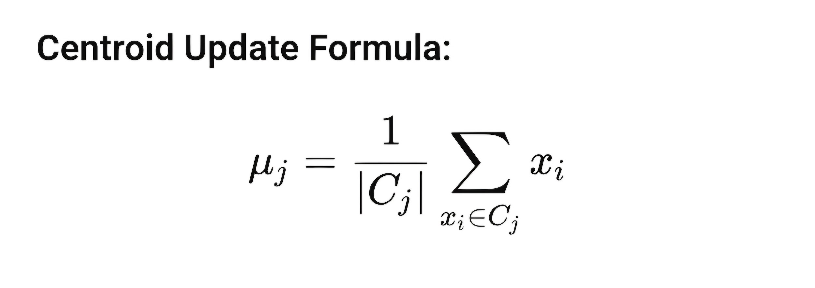

Advantages:

● Simple and fast
● Works well with spherical clusters

Limitations:

● Sensitive to initial centroids

● Struggles with non-globular cluster shapes

6. Principal Component Analysis (PCA)
PCA is used for dimensionality reduction and visualization of high-dimensional data by preserving variance.

Procedure:

- Standardize the dataset features.

- Compute the covariance matrix.

Calculate eigenvectors and eigenvalues.

Select the top N principal components.

Transform the data using selected components.

Use reduced data for further modeling or visualization.
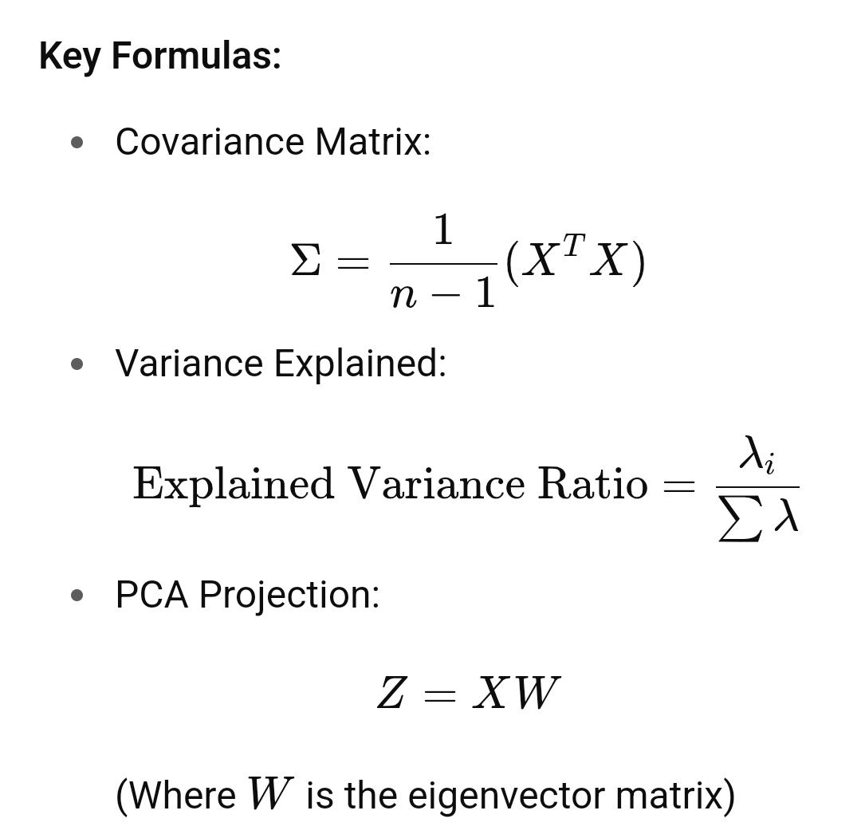
Advantages:

●Reduces overfitting

●Speeds up computation

Limitations:

●Principal components may not be easily interpretable

7. Association Rule Mining (Apriori Algorithm)
Apriori finds frequent itemsets and generates association rules to reveal hidden patterns in data.

Procedure:

Convert data into a transactional format.

Define minimum support and confidence thresholds.

Use the Apriori algorithm to find frequent itemsets.

Generate association rules from the itemsets.

Evaluate rules using confidence, lift, and support.
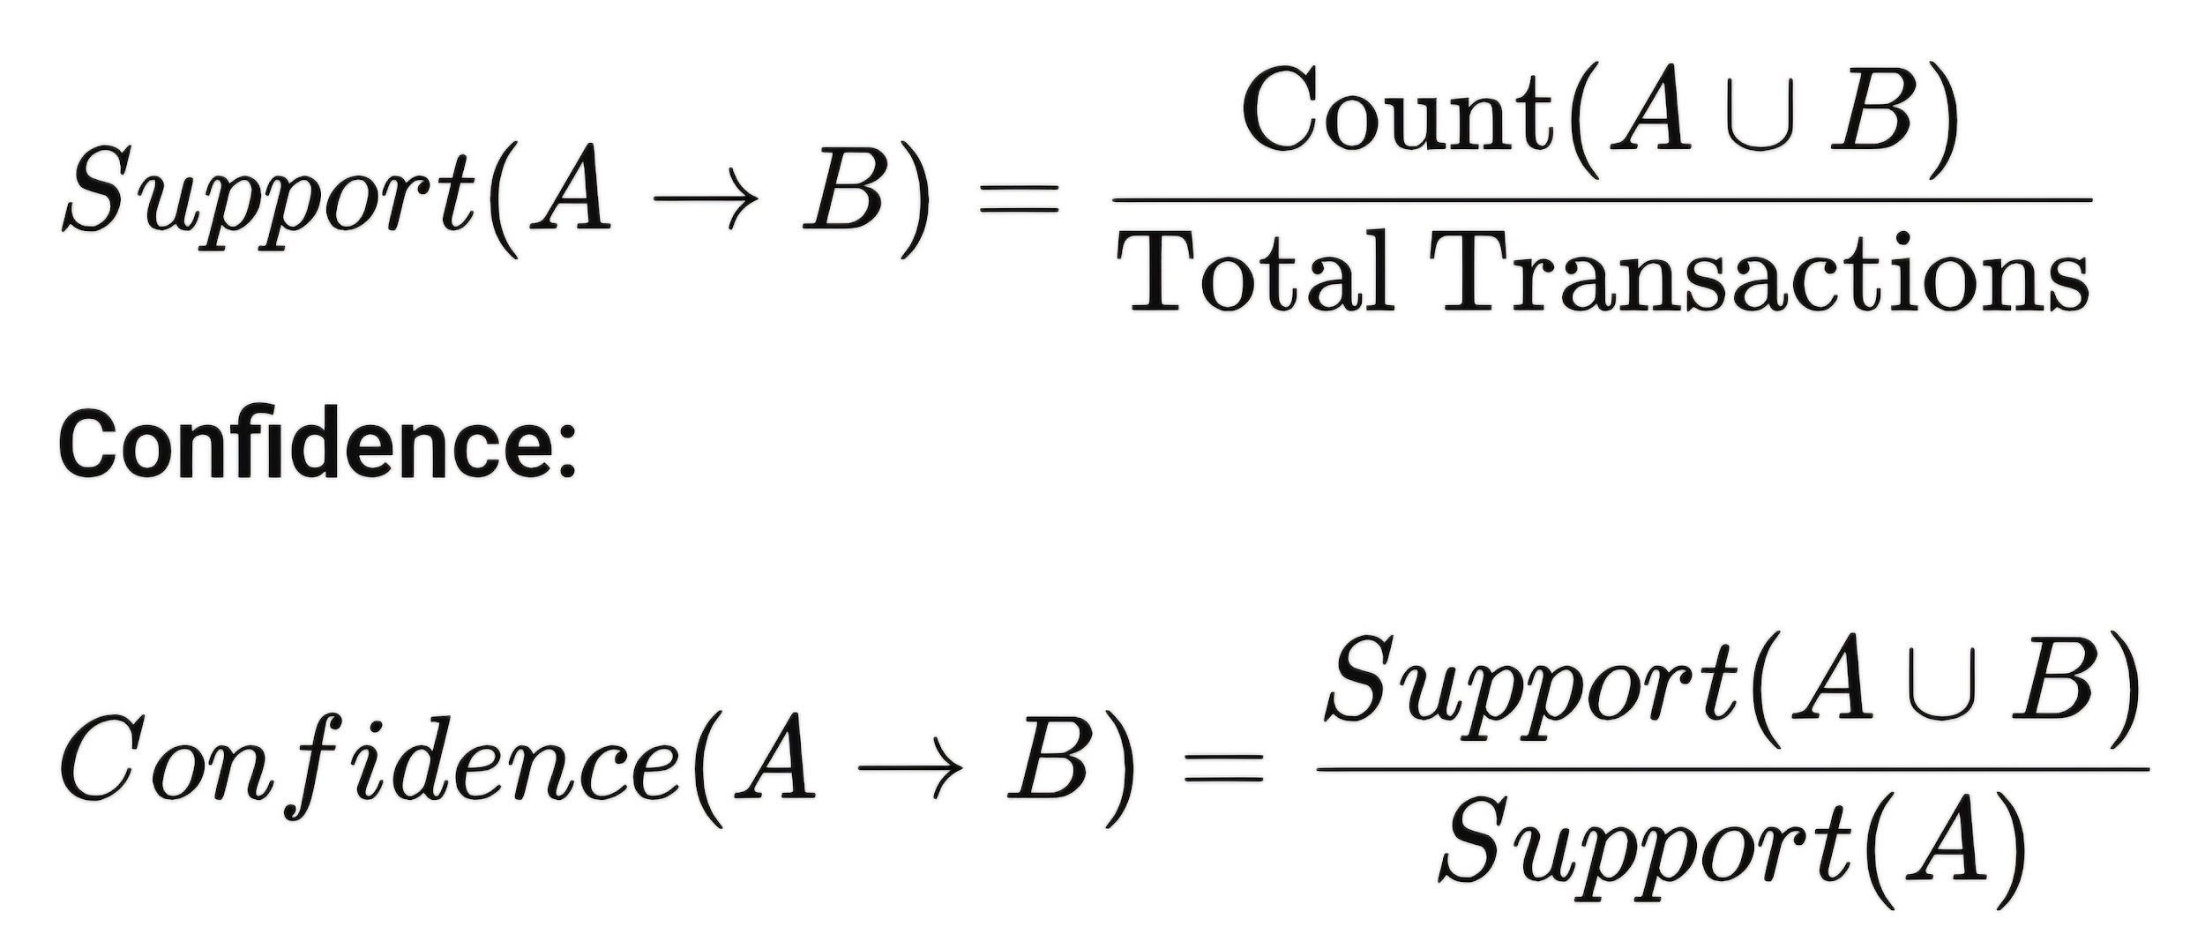
Advantages:

●Useful for market basket analysis

●Can uncover hidden patterns

Limitations:

●May generate too many rules

●Computationally intensive for large datasets
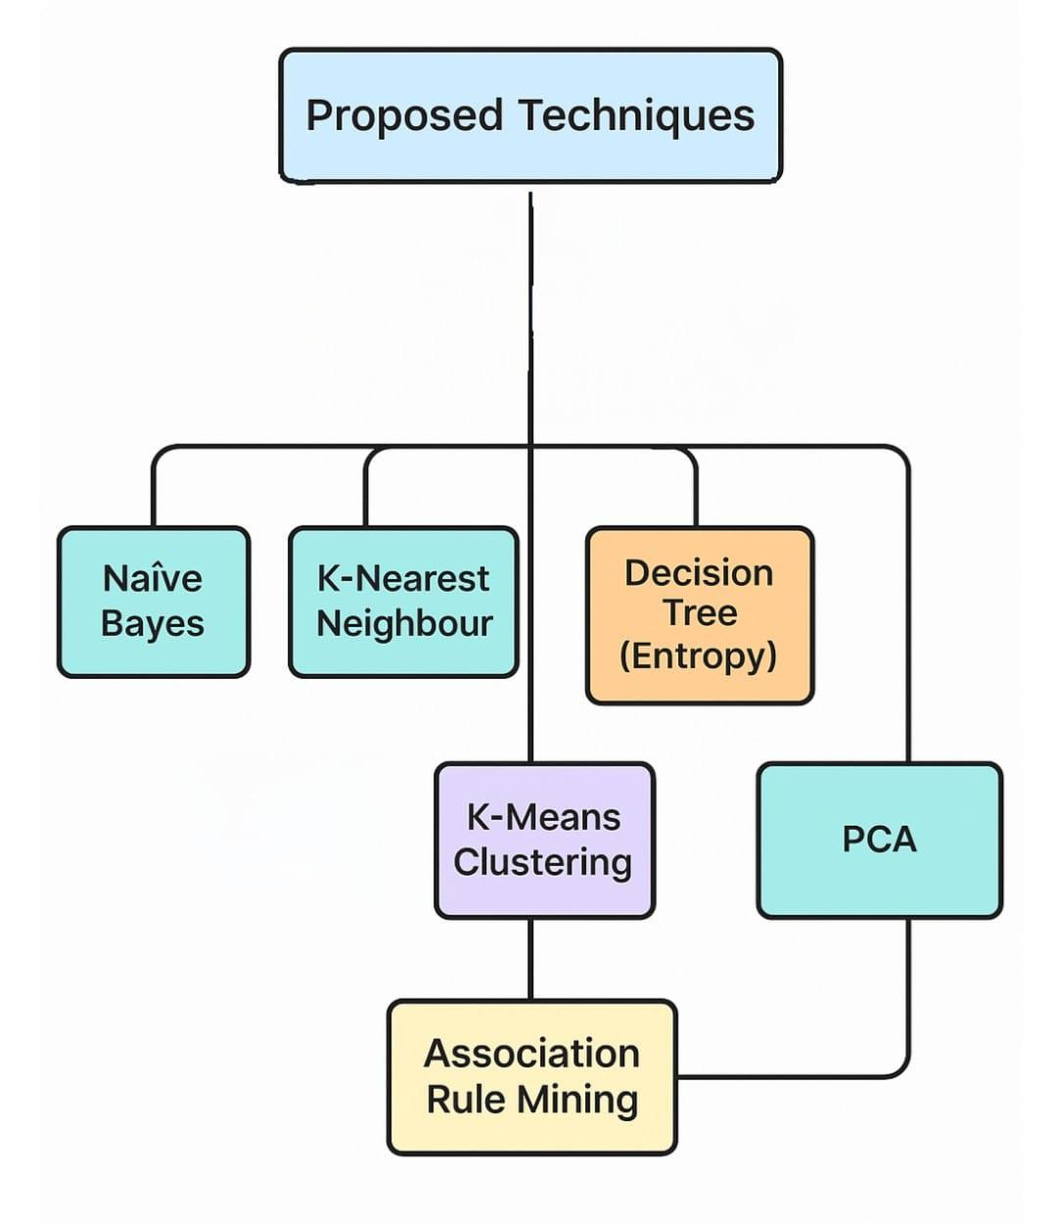

Experiments and Results
Experiment and Results: Breast Cancer Wisconsin Dataset Analysis

This experiment utilized the Breast Cancer Wisconsin Dataset to perform a comprehensive analysis, including data preprocessing, feature selection, supervised classification, unsupervised clustering, dimensionality reduction, and association rule mining. The dataset contains 569 samples with 30 numerical features describing tumor characteristics and a target variable (`diagnosis`) indicating whether the tumor is malignant (M) or benign (B). The primary objectives were to evaluate multiple machine learning models for classification, identify key features influencing diagnosis, and uncover patterns in the data through clustering and association rules.

### Dataset Description
- **Shape**: 569 samples, 33 columns (including `id`, `diagnosis`, 30 features, and an `Unnamed: 32` column).
- **Features**: 30 numerical features (e.g., `radius_mean`, `texture_mean`, `concave points_worst`).
- **Target**: `diagnosis` (M = Malignant, B = Benign; encoded as 1 and 0, respectively).
- **Preprocessing**:
- Dropped `id` and `Unnamed: 32` (completely empty) columns.
- No missing values were found in the feature columns.
- Features were scaled using `StandardScaler` for model compatibility.
- Target was encoded using `LabelEncoder` (M=1, B=0).

### Methods
The experiment involved the following methodologies:
1. **Feature Selection**:
- Calculated Information Gain, Split Information, and Gain Ratio for each feature to assess their relevance to the target.
- Used median-based discretization for feature splitting.
2. **Supervised Classification**:
- Models: Naive Bayes, K-Nearest Neighbors (KNN, k=5), Decision Tree (Gini), Decision Tree (Entropy).
- Train-test split: 80% training, 20% testing (random_state=42).
- Metrics: Accuracy, Precision, Recall, F1 Score (weighted averages).
3. **Unsupervised Clustering**:
- Applied K-Means clustering (k=2) to identify natural groupings in the scaled data.
4. **Dimensionality Reduction**:
- Performed Principal Component Analysis (PCA) to reduce features to 2 components for visualization.
- Visualized PCA results and K-Means clusters, highlighting top contributing features.
5. **Association Rule Mining**:
- Selected top 10 features based on Gain Ratio.
- Converted features to binary (high/low based on median).
- Applied Apriori algorithm (min_support=0.3, max_len=4) and generated association rules (min_confidence=0.6).
6. **Decision Tree Visualization**:
- Visualized Decision Trees (Gini and Entropy) to interpret feature splits.
7. **Feature Importance**:
- Extracted feature importance from Decision Tree (Entropy) to identify key predictors.

## Results
Experiment Overview
### 1. Feature Selection
The top 5 features by Gain Ratio, which measures the normalized Information Gain, were:

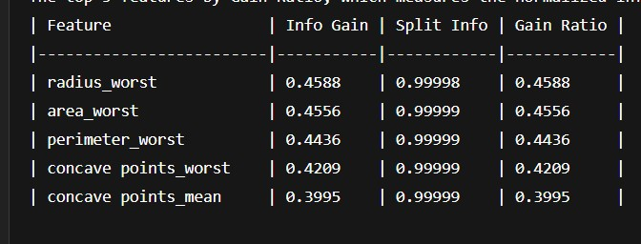

**Observation**: Features related to tumor size (`radius_worst`, `area_worst`, `perimeter_worst`) and shape (`concave points_worst`, `concave points_mean`) were the most informative for distinguishing between malignant and benign tumors.

### 2. Model Performance
The performance of the four classification models on the test set is summarized below:
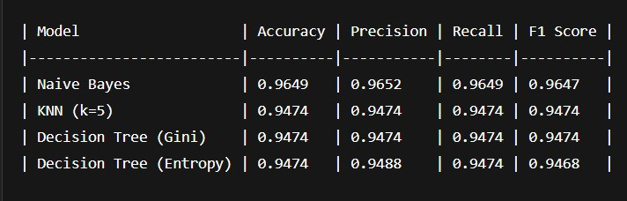
**Key Findings**:
- **Naive Bayes** achieved the highest performance across all metrics, with an F1 Score of 0.9647, indicating robust classification despite its assumption of feature independence.
- **KNN** and both **Decision Trees** performed comparably, with F1 Scores around 0.947, suggesting good but slightly less effective classification than Naive Bayes.
- **Recommendation**: Naive Bayes is recommended for this dataset due to its superior F1 Score, reflecting a balanced trade-off between precision and recall.

### 3. Clustering
K-Means clustering (k=2) was applied to the scaled features. The clusters were visualized using PCA, with centroids marked. The clustering results were compared to the true diagnosis labels in the PCA plot.

**Observation**: The clusters showed moderate alignment with the true labels (benign vs. malignant), indicating that the features contain natural groupings that partially correspond to the diagnosis.

### 4. PCA Visualization
PCA reduced the 30 features to 2 components for visualization:
- **PC1** (explained 44.27% variance): Most influenced by `concave points_mean`.
- **PC2** (explained additional variance): Most influenced by `fractal_dimension_mean`.

**Top 5 Features by PCA Component Contribution** (sum of absolute weights):
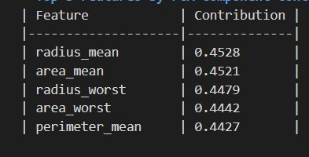

**Observation**: PCA confirmed that size-related features (`radius`, `area`, `perimeter`) dominate the variance in the dataset, consistent with feature selection results.

### 5. Association Rule Mining
Using the top 10 features by Gain Ratio, the Apriori algorithm identified:
- **Frequent Itemsets**: 385 itemsets (min_support=0.3).
- **Association Rules**: 3750 rules (min_confidence=0.6).

**Top 5 Frequent Itemsets**:
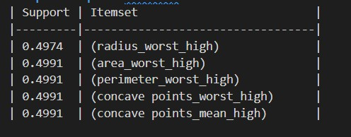

**Sample Association Rules**:
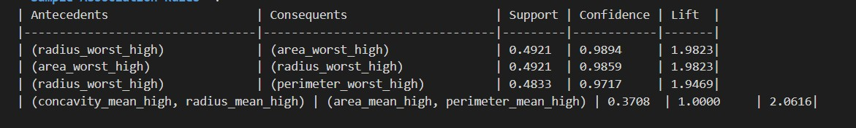

**Observation**: Strong associations exist between high values of size-related features (e.g., `radius_worst`, `area_worst`, `perimeter_worst`), with high confidence and lift values indicating that these features often co-occur in malignant cases.

### 6. Feature Importance (Decision Tree Entropy)
The top 5 features by importance from the Decision Tree (Entropy) were:
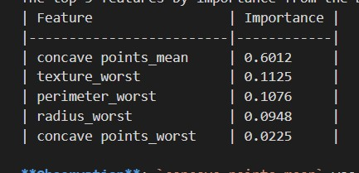

**Observation**: concave points_mean was the most critical feature for splits in the Decision Tree, aligning with its high Gain Ratio and PCA contribution.
7. Visualizations - **PCA Plot**: Showed clear separation between benign and malignant samples along PC1 (concave points_mean).
- **K-Means Clustering Plot**: Highlighted two clusters with centroids, showing partial overlap with true labels. - **Decision Tree Visualizations**: Illustrated splits primarily driven by concave points_mean and size-related features, with interpretable decision paths. ## Discussion - **Model Performance**: Naive Bayes outperformed other models, likely due to the dataset's feature distributions approximating conditional independence after scaling. KNN and Decision Trees were slightly less effective, possibly due to sensitivity to feature scaling (KNN) or overfitting risks (Decision Trees)
. - **Feature Importance**: Features like concave points_mean, radius_worst, and perimeter_worst consistently appeared as critical across feature selection, PCA, and Decision Tree importance, indicating their strong predictive power for tumor malignancy. - **Clustering**: K-Means clustering revealed natural groupings, but the overlap suggests that additional features or clusters may improve separation. - **Association Rules**: The high number of rules reflects strong correlations among size and shape features, particularly in malignant cases, which could inform clinical decision-making. - **Limitations**: The dataset had no missing values, simplifying preprocessing, but real-world data may require more robust imputation. The high number of association rules may include redundant patterns, necessitating further filtering.

Conclusion

This report explored two key data mining techniques—K-Means clustering and Principal Component Analysis (PCA)—to gain insights into the structure of breast cancer data. Using K-Means with two clusters, the data was effectively partitioned based on scaled features such as Radius Mean and Texture Mean. The resulting scatter plot revealed a reasonably clear distinction between the clusters, with centroids marked prominently. Although the separation wasn’t perfect, the visualization demonstrated that clustering can help reveal natural groupings in the data, suggesting these features carry meaningful variance, possibly linked to benign and malignant classes.Complementing this, PCA was applied to reduce the high-dimensional data into two principal components, explaining 63.24% of the total variance. The PCA scatter plot illustrated how benign (blue) and malignant (red) samples cluster in the reduced space. The first principal component, strongly influenced by the concave points_mean feature, explained 44.27% of the variance and was particularly effective in separating the classes along the x-axis. However, noticeable overlap between the classes in the central region indicates the complexity of the dataset and highlights that a linear separation may not fully capture the underlying class distinctions.Together, K-Means and PCA provide valuable exploratory insights. The clustering results demonstrate potential groupings, while PCA offers evidence of key features influencing class separation. However, both methods also underscore the need for more advanced classification models and the inclusion of additional features to improve accuracy and uncover deeper patterns in the data.
(250 Words)

References
[add list of references here (al least 20 research articles)]
First Reference
Second Reference
…..

Appendix

